OCD FAMILY SUPPORT GROUP
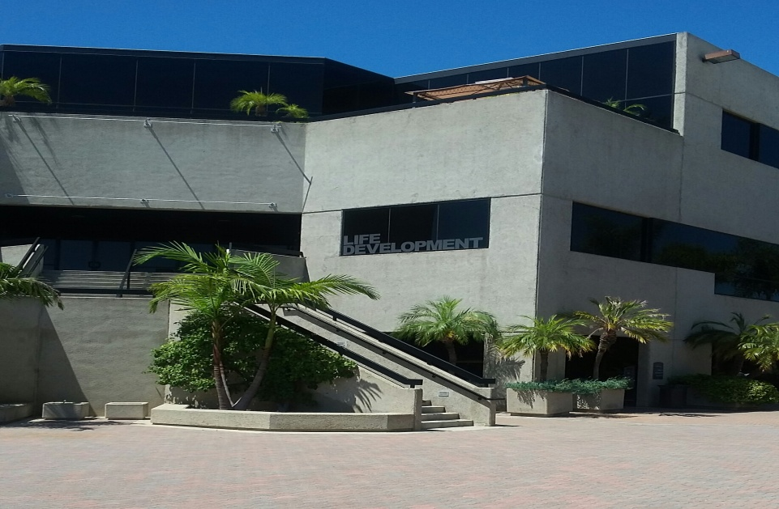
The OCD Family Support Group meets at the Mariner’s Church in Irvine
We meet on the second Saturday of each month, from 11:00 AM to 1:00 PM
The church is located at 5001 Newport Coast Drive in Irvine
Directions:
From 73 S: Take the Bonita Canyon Drive (exit 12). Turn right onto Bonita Canyon Drive and turn right on Turtle Ridge. Turn right on Federation Way. The parking lot is immediately on the right.
From 405 S: Take MacArthur Blvd South (exit 8). Turn left at the end of the ramp. Continue on MacArthur and make a left on Bonita Canyon Drive. Turn right on Turtle Ridge. Turn right on Federation Way. The parking lot is immediately on the right.
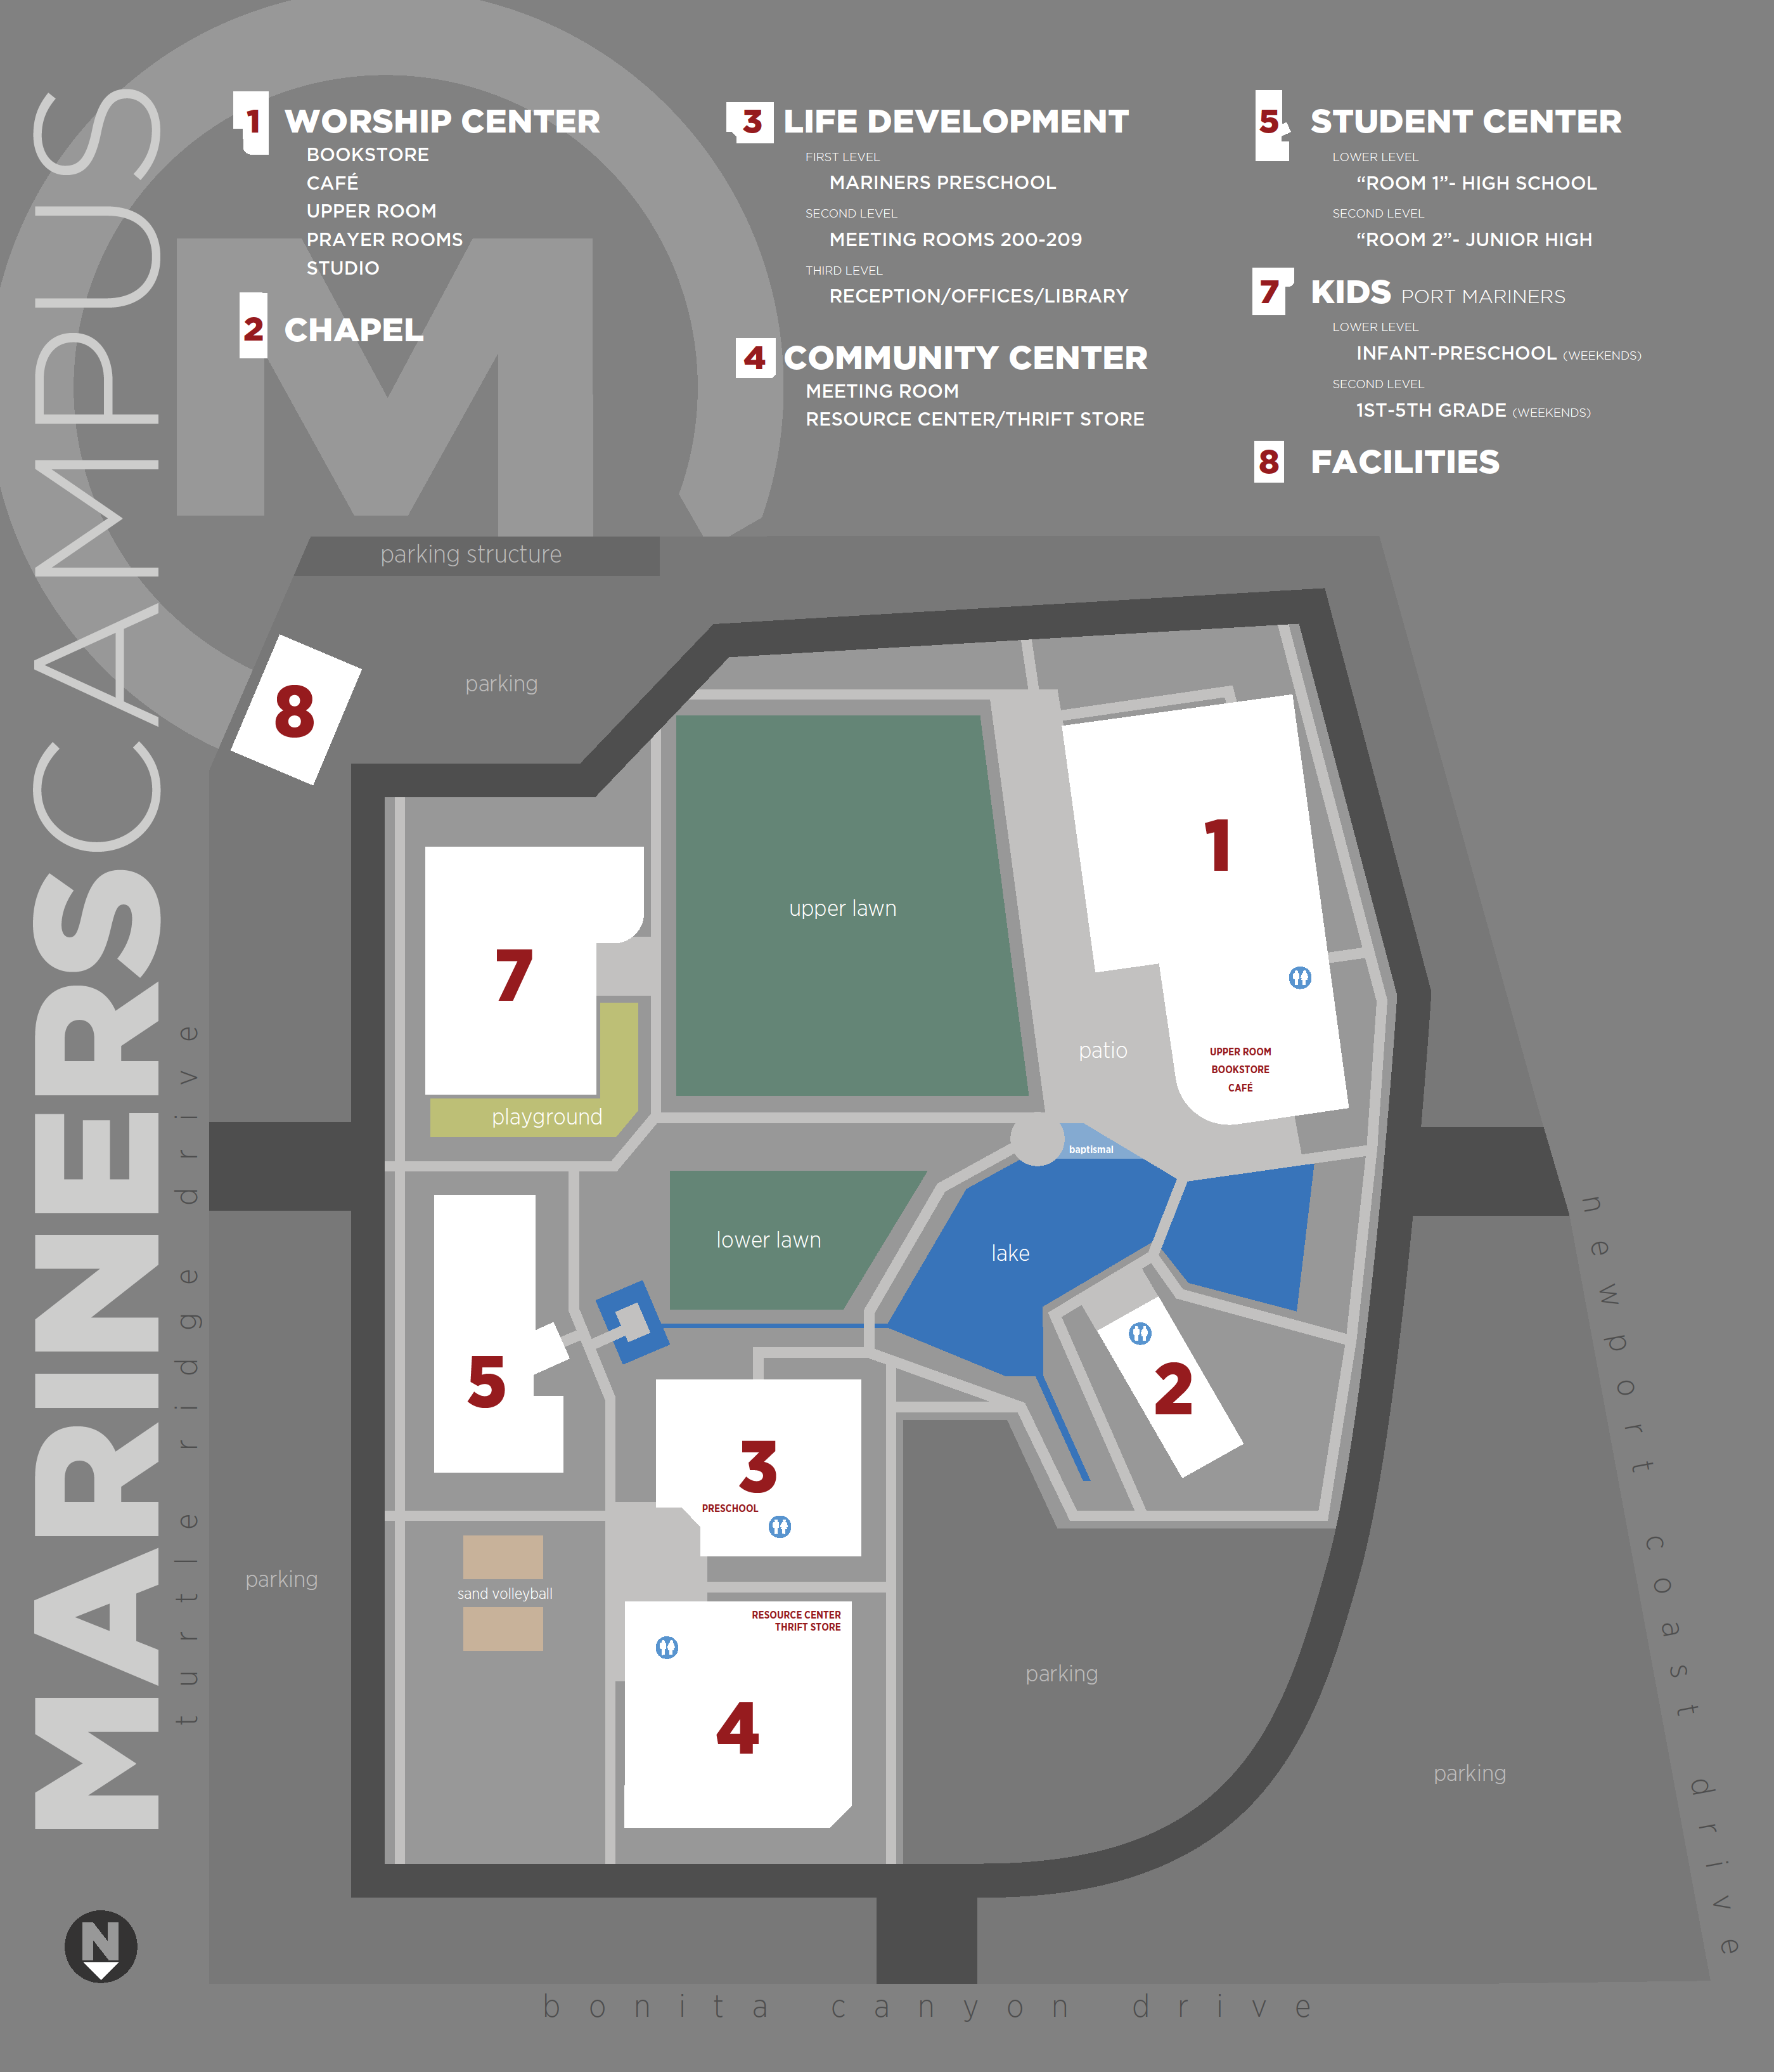
We will meet in the Life Development Center
Room 209
For more information about the Support Group, contact Liz at 562-213-2191
If you need help on the day of the meeting, contact any of the following people:
Jurhee 714-655-2491
Chris 714-642-6837
Mary 310-961-0225

ENTER
PARK
Bonita Canyon Drive
Newport Coast Drive

